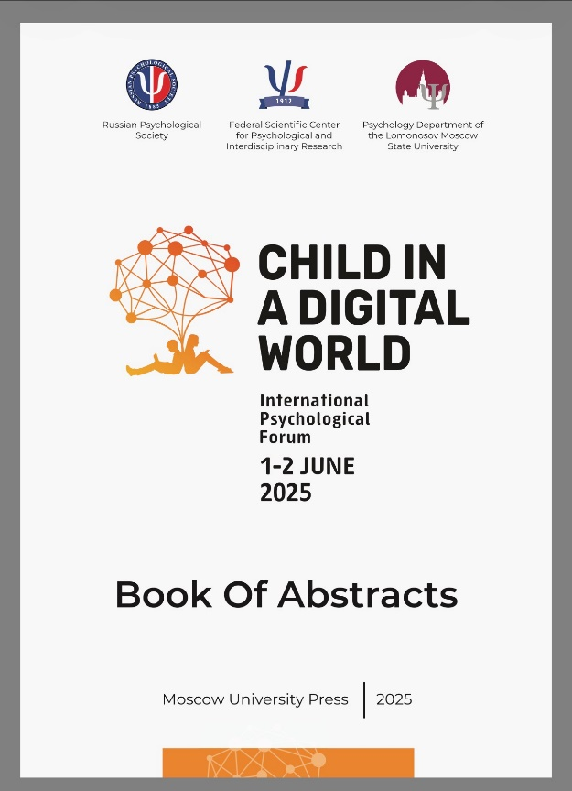 | Anastasia Yuldasheva  Didactic and technological analysis of digital educational products for children with disabilities. // Child in a digital world. 2025. C.113-114  DOI: 10.61365/forum.2025.081
Abstract: Digitalization of preschool education for children with disabilities is in demand by society, but there are no clear criteria for the development and selection of digital tools. This leads to a variety of products of varying quality. Scientific development of such criteria will improve the effectiveness of inclusive education and reveal the potential of new technologies. Objective of the study: analyzing existing types of digital educational products for preschoolers with disabilities and comparing them with the special educational needs of children, regulations and pedagogical recommendations for training to identify requirements for the development of didactic content and technological characteristics of digital products. Research methods and sample: analysis of regulatory documents and methodological literature, including information on the content and organization of the educational process for preschoolers with disabilities; study of data from technical methodological literature
touching on issues of designing game mechanics; drawing up a protocol for studying digital tools and methodological materials for them; analysis of digital educational tools developed for children with disabilities. Main results. The analysis of standards revealed the criteria of hygiene and compliance with programs for digital tools of preschool education. Methodological literature added pedagogical requirements, technical literature added parameters of accessibility and content structure. Of the assessed tools, only meet all the requirements, showing the gap between the needs of education and real practice. Conclusion. At the current stage of development of the digital educational space, there is a shortage of products, the quality of which allows
realizing the potential of the digital form of education of preschoolers with disabilities. The organization of the digital didactic space taking into account the relevant technical and pedagogical requirements will allow consolidating and modifying the child’s practical experience, developing the symbolic function of thinking, preparing children for the next stage of education and for life in the modern world. In this regard, this study needs to be continued to formulate detailed requirements for the development and selection of digital products.
Keywords: digital products, children with disabilities, preschool education

