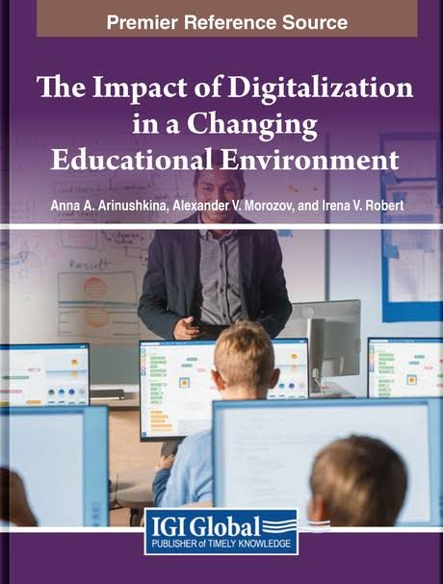 | Kochetova E. A., Francisco Javier Castillo Vado, Solovyova T. A., Boldinova O. G. Digitalization of Education for Students With Disabilities in Nicaragua and Russia / E. A. Kochetova, Francisco Javier Castillo Vado, T. A. Solovyova, O. G Boldinova // The Impact of Digitalization in a Changing Educational Environment. – 2023. – Chapter 19 – Pages 242-251.

Аннотация: The research examines the content of digitalization of education for students with disabilities in Nicaragua and Russia. The authors outline topical issues related to the individual-differentiated approach in the use of digital technology in special and inclusive education. The research aims to compare and evaluate the use of advanced digital technologies developed for students with disabilities in Nicaragua and Russia. The authors determined the special conditions of digitalization of education for students with disabilities, considering special educational needs and academic opportunities, and provided recommendations for teachers of educational organizations related to the use of digital technology. The research results can be applied during digitalization of education for students with disabilities.

