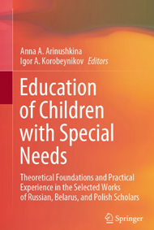 | Belikova, A.I., Solovyova, T.A., & Kaganov, V.S. (2022). Financial Literacy as a Special Subject of Research, Formation, and Development in the Structure of Life Competence of Schoolchildren with Special Educational Needs. In A.A. Arinushkina, & I.A. Korobeynikov (Eds.), Education of Children with Special Needs: Theoretical Foundations and Practical Experience in the Selected Works of Russian, Belarus, and Polish Scholars (pp. 107-113). Cham, Switzerland: Springer. https://doi.org/10.1007/978-3-031-13646-7_12
Abstract The problem of financial literacy of young people, including those with disabilities, is one of the state importance in the system of education. To form general and special competencies in the field of financial literacy of persons with disabilities and impairments, a draft Glossary of Financial Terms for Persons with Disabilities was prepared. The Glossary can be considered as a tool for users with disabilities, social and pedagogical workers, and other interested professionals. The research subject is the financial literacy of persons with impairments and disabilities, the analysis of the level of financial literacy of adolescents attending boarding schools, the features of their perception of information, and the level of socialization in the financial sphere.
Keywords Adolescents • Schoolchildren with disabilities • Financial literacy • Glossary of financial terms • Life competencies

