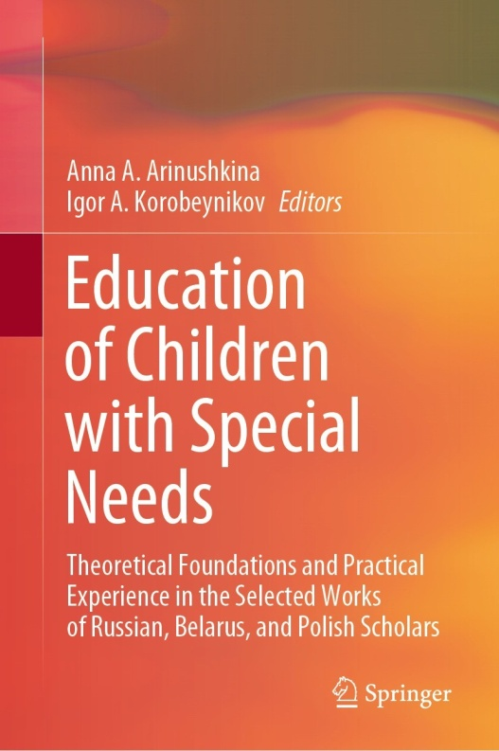 | Sviridova, T.V., Gerasimova, A.M. (2022). Organization of Education for Children with Cystic Fibrosis in the Hospital. In: Arinushkina, A.A., Korobeynikov, I.A. (eds) Education of Children with Special Needs . Springer, Cham. https://doi.org/10.1007/978-3-031-13646-7_41

Abstract: The paper aims to examine the psychophysical state and special educational needs of children with cystic fibrosis as factors influencing the organization of the educational process during hospitalization. The authors apply several research methods such as the analysis of medical and pedagogical documentation, the “PedsQL 4.0” questionnaire, and conversations with doctors and teachers. The authors establish that to implement the children’s legal right to education in the conditions of prolonged hospitalization, it is necessary to focus on their psychophysical functioning. It is established that children with sufficient physical and psychological functioning (16%) can be included in the educational process according to the program recommended by the psychological, medical, and pedagogical commission. Due to a slight decrease in work capacity and time restrictions due to the treatment regimen, it is necessary to reduce the study load by reducing the number of subjects (to 3–5 lessons per day), filling the program in an equal amount with new material and tasks to consolidate previously learned knowledge. Patients with average indicators of physical and psychological functioning (70%) who are in a moderately severe condition due to a recurrent course of the disease are shown an individual study plan with a reduction in the number of subjects (to 2–3 lessons per day) and filling its content with repetition of passed material. Considering the significant exhaustion of children and the high load of therapeutic measures, classes are conducted in the first half of the day with a minimum number of tasks for independent work. The third group (14%) is represented by children with low physical and psychological functioning indicators, which included patients in severe and moderate conditions. The education of this group in the situation of disease exacerbation should be carried out according to an individual program, including the subjects of additional education and considering the child’s preferences. The research novelty lies in the scientific justification of the need to implement a differentiated approach in the education of children with rare diseases. A targeted approach in the process of teaching children with severe chronic diseases will help create favorable developmental conditions for specialists in the psychological and pedagogical profile (teachers, psychologists) in the hospital and in the educational organization at the place of residence, improve the quality of life of children and their families.
Keywords: Children with disabilities, Disabilities, Pedagogical innovations, Quality of life, Pedagogical support, Pediatric hospital

