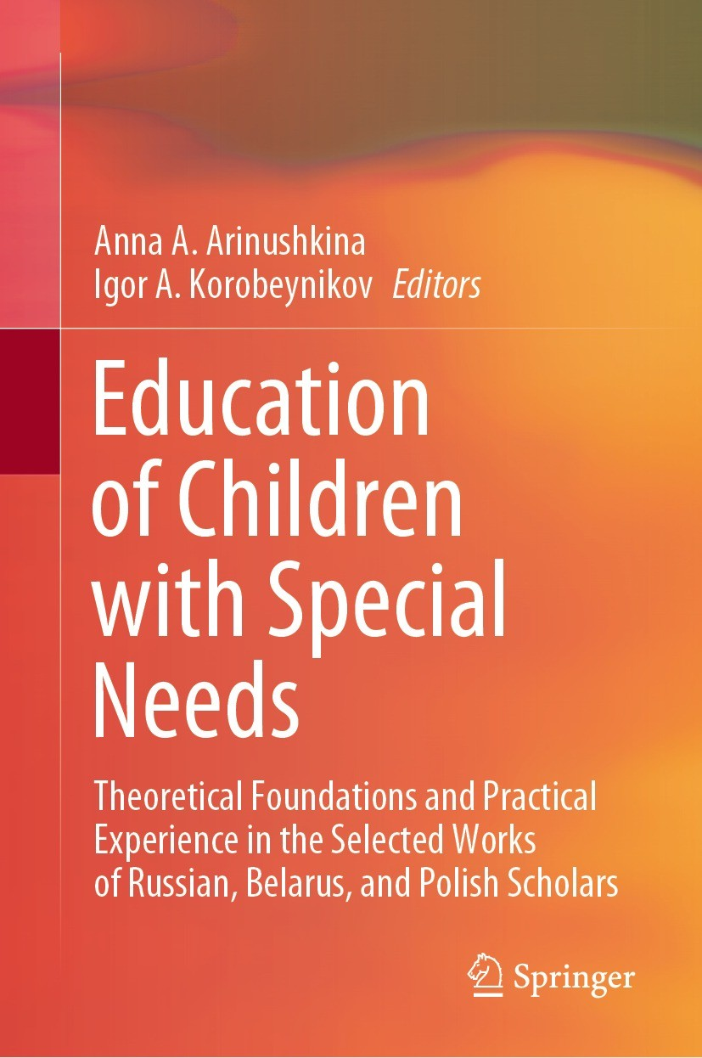 | Nurlygayanov, I.N., Korobeynikov, I.A. (2022). Historical Reconstruction of the Definitions of Russian Special Pedagogy and Psychology. In: Arinushkina, A.A., Korobeynikov, I.A. (eds) Education of Children with Special Needs . Springer, Cham. https://doi.org/10.1007/978-3-031-13646-7_34

Abstract
The paper aims to trace the transformation of the categorical and conceptual definitions of Russian special psychology and pedagogy on the example of publications in the journal “Defectology.” The authors highlight the categories of persons with developmental disorders, which most often acted as the subject of studies in different periods. The authors reveal the regularities of the publication activity of scientists concerning different groups of impaired development. Additionally, the authors show the evolutionary transition of the professional community to using humanitarian-oriented terminology in relation to people with disabilities.
Keywords: Special pedagogy and psychology, Categorical and conceptual definitions, Journal “Defectology”, Terminology, People with disabilities

