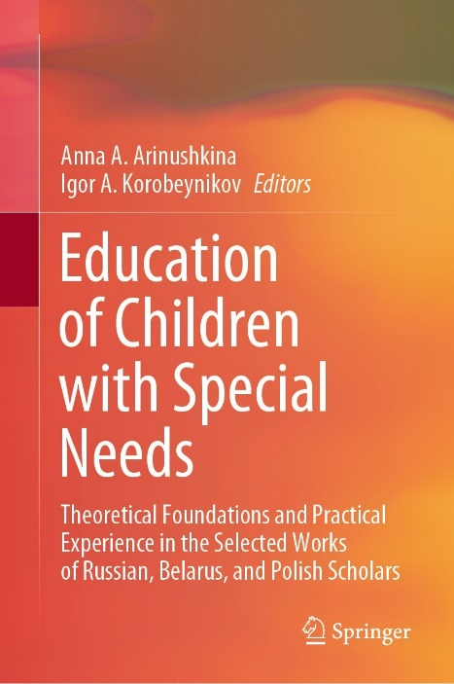 | Grigorieva, N.A., Lazurenko, S.B., Solovyova, T.A. (2022). Models of Inclusive Education for Children with Disabilities in International Practice: Historical Experience and Current Trends. In: Arinushkina, A.A., Korobeynikov, I.A. (eds) Education of Children with Special Needs . Springer, Cham. https://doi.org/10.1007/978-3-031-13646-7_32

Abstract: The paper aims to identify and classify the main groups of models of inclusive education for children with disabilities presented in international practice over the past three decades. The research object is the historical experience of the development of public policy in the field of inclusive education in countries with different educational systems and economic conditions. The authors pay particular attention to the dynamics of the formation and development of inclusive education models in the context of public policy objectives. It is emphasized that inclusive education remains the primary public mechanism for translating key social attitudes and values, maintaining the possibility of dialogue between generations, and providing a balanced combination of traditions and innovations in understanding current social relations towards children with disabilities. The methodological basis of the research consists of the principles of historicism, scientific objectivity, consistency, and comprehensiveness, which allow us to study the experience and current trends in the creation and development of existing models of inclusive education as a complex problem, analyzing the factual material in its totality and interconnection. The primary results and conclusions of the research are the essential characteristics of the models of inclusive education and features of their development in the context of public policy of different countries in 1990–2000. A special contribution of the authors to the research in this area is a comprehensive analysis of the evolution of approaches to creating and developing inclusive education models over recent decades. The research novelty lies in the systematization of the main groups of models of inclusive education of children with disabilities, presented in international practice.
Keywords: Educational models, Public policy, Children with disabilities, Inclusion

