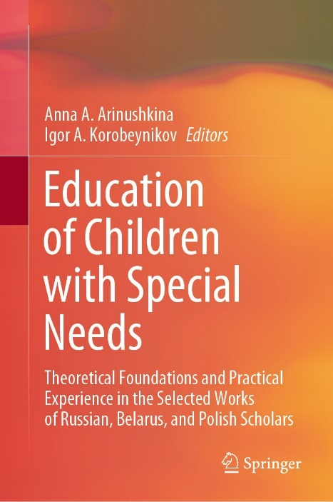 | Golubchikova, A.V., Lazurenko, S.B. (2022). Digital Game Aids in the Rehabilitation of Children with Disabilities. In: Arinushkina, A.A., Korobeynikov, I.A. (eds) Education of Children with Special Needs . Springer, Cham. https://doi.org/10.1007/978-3-031-13646-7_3

Abstract: The paper reveals the prospects of using digital game technologies to diagnose and rehabilitate children with disabilities. The paper aims to classify game products with digital components from the perspective of restoring health and improving the quality of children’s life. The authors present the results of a comprehensive analysis of game products with digital components over the past decade. Particular attention is paid to the design and technical characteristics of the products. Additionally, the authors describe the mechanism of the impact of smart toys on children’s physical or mental state. The scientific novelty of the research lies in the definition of criteria for classifying smart toys into groups for their reasonable use in the rehabilitation process of children with disabilities. The proposed approach to the design and classification of digital game products will form a new level of diagnosis and correction of mental functions of children for professionals. Smart toys are aninnovative form of organizing play activity, which increases the child’s cognitive interest and contributes to faster achievement of the intended rehabilitative goals.
Keywords: Digital technology, Smart toy, Data collection, Rehabilitation, Diagnostics, Children with disabilities

