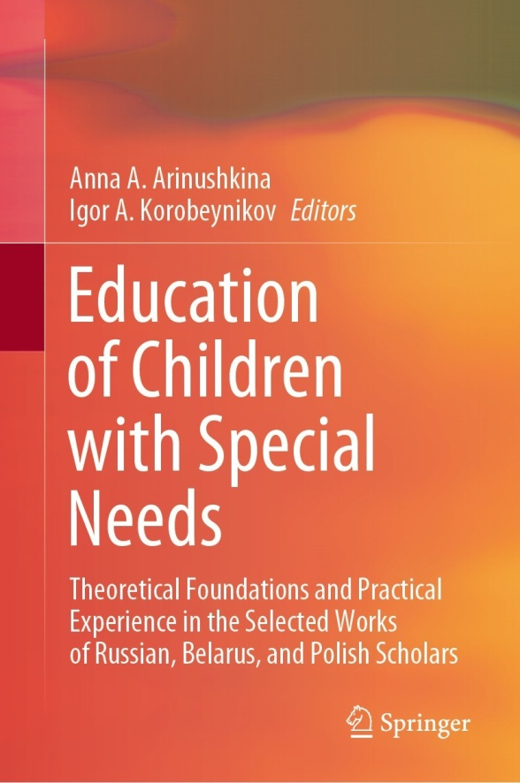 | Brutskaya, K.A. (2022). The Transformation of the Role of the Third Generation in Raising Children with Disabilities in the Family: Retrospective Analysis. In: Arinushkina, A.A., Korobeynikov, I.A. (eds) Education of Children with Special Needs . Springer, Cham. https://doi.org/10.1007/978-3-031-13646-7_45

Abstract: Performing many roles in raising children with disabilities, the third generation (grandparents) has a tremendous impact on the formation of the child’s personality. The third generation most often provides nursing, care, family support, and assistance in raising a child with disabilities. However, the study of the role of the third generation in the life of a young family has not been adequately reflected in contemporary psychological science, both in terms of specific scientific research and practical developments of psychological and pedagogical assistance to parents raising a child with disabilities. This research considers the transformation of the role and place of the third generation in raising children with disabilities. In general, a retrospective analysis showed that for the early stages of the development of human society, the representatives of the older generation are the keepers of knowledge and wisdom. At the current stage of social development, there appears a phenomenon of “gerontological ageism.” The author focuses on the concept of “mutual assistance” between generations of the Soviet family and the current Russian family, raising a child with disabilities. The scientific novelty of the research lies in the fact that the study of the role and degree of participation of the third generation in raising children with disabilities was carried out using a content analysis of the free statements of respondents who were asked to complete the sentence “My mother (grandmother) and dad (grandfather) for me are…” As a result of the content analysis, the respondents’ statements were distributed into 145 completed lexical units, which, in terms of psychological content, merged into semantic categories reflecting the role of the third generation in the life of parents of the second generation. The conclusions of the research can be useful to teaching staff engaged in psychological and pedagogical support for children with disabilities in the process of improving the qualifications of specialists in psychological and pedagogical support, as well as for parents raising children with disabilities. The results of the research will optimize the processes of interpersonal interaction in families, including parent–child relationships and the relationship of grandparents with their grandchildren, which will lead to the creation of optimal intrafamily conditions for the harmonious development of a child with disabilities and improve the educational competence of family members.
Keywords: Third generation, Social structure, Family values, Communication of generations, Support of parents of people with disabilities, Semantic categories, Mutual assistance of close relatives

