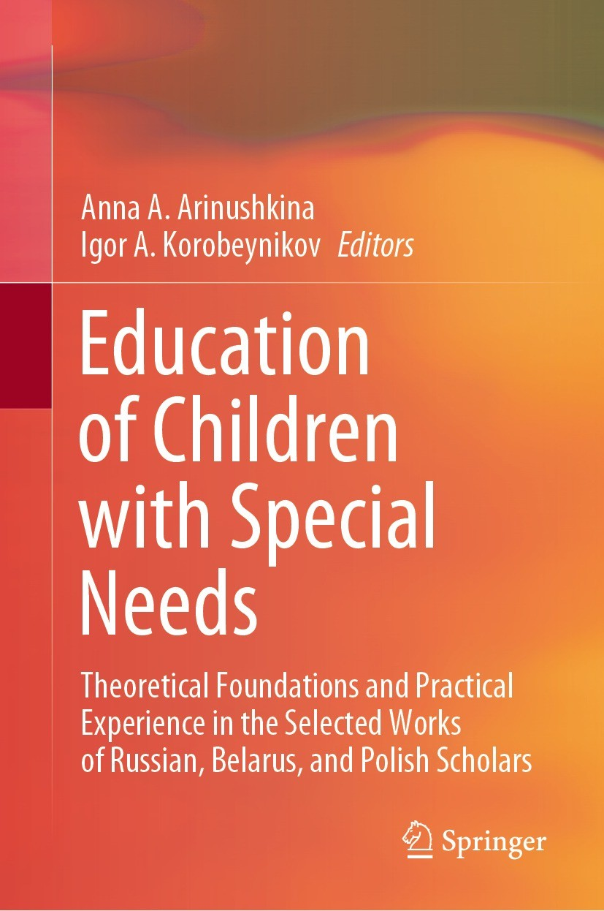

Nikolay V. Romanovsky, Galina Itskovich, Olesya E. Strikha (2022). Trialability of FEAS Structured Observation Scale on a Sample of Russian-Speaking Children. In: Arinushkina, A.A., Korobeynikov, I.A. (eds) Education of Children with Special Needs. Springer, Cham. https://doi.org/10.1007/978-3-031-13646-7_30

Abstract
This paper presents an experiment in replicated administration of the FEAS (Functional Emotional Assessment Scale) structured observation scale using a sample of Russian-speaking children. This scale was created using the developmental theory of functional and emotional capacities (FEDC) and presents a method used to evaluate children aged from seven months to four years being at risk or having a delay in the development of social skills, attachment, play skills, and overall emotional development. The research involved 23 pairs of parents and children aged 2.2–4 years. In the sample, 12 children showed symptoms of autism spectrum disorders, and 11 children were developing normatively. The results of the FEAS scale study correspond to the results obtained by S. Greenspan on the American sample in a study described in 1992. The study results using the FEAS scale were compared to the RCDI-2000 (CDI) scale data obtained on the same sample. Correlation analysis of the results proves the connection between the social skills of a child, the complexity of his or her speech, and abilities to establish a close and warm relationship while interacting with a caregiver, show initiative, and develop play ideas. The widespread use of this methodology in the Russian-speaking space can help improve the competence of practitioners working with families of special children, because they will have a structured protocol for assessing and setting goals and objectives for working with families. Parents of children with special needs can increase their competence in establishing a developmental relationship with their children, which will positively affect the process of rehabilitation of children with special needs.

Keywords: Diagnostics, Social-emotional development, Early life, Developmental disorders, Autism spectrum disorders, Parent–child relationships, Family of a child with developmental disorders, Early intervention, FEAS.

