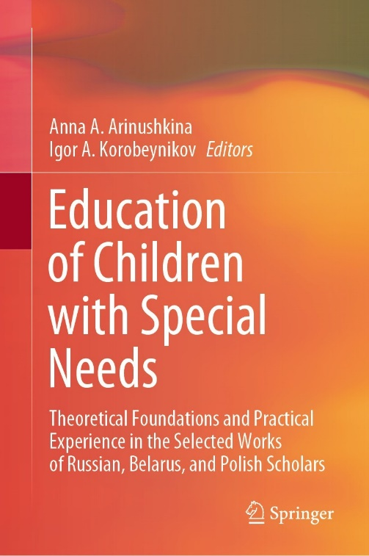 | Zakrepina, A.V., Strebeleva, E.A., & Martyshevskaya, D.M. (2022). Experimental Study of Mental Activity in Children with Severe Traumatic Brain Injury: Structural and Comparative Analysis. In A.A. Arinushkina, & I.A. Korobeynikov (Eds.)/ /, Education of Children with Special Needs: Theoretical Foundations and Practical Experience in the Selected Works of Russian, Belarus, and Polish Scholars (pp. 345-352). Cham, Switzerland: Springer. https://doi.org/10.1007/978-3-031-13646-7_35  ISBN: ‎978-3031136450) в издательстве Springer Nature Switzerland AG.
Abstract
The paper presents the results of a study in which indicators of social and cognitive abilities in the early stages of traumatic illness are highlighted by a comparative analysis of the structure of mental activity of toddlers and preschool children with severe traumatic brain injury (severe TBI). These results can serve as guidelines for selecting differentiated strategies of corrective and pedagogical assistance at the initial stage of rehabilitation of children of the studied groups in conditions of comprehensive rehabilitation. The paper aims to search for specific manifestations in the structure of mental activity with severe injury in children of two age groups based on a comparison of indicators. The experimental study involves 65 preschool children (28 girls and 37 boys) and 45 toddlers (18 girls and 27 boys). Research methods include analysis of medical data, conversation with parents, pedagogical observation, psychological and pedagogical examination, and statistical methods of processing the research results. According to clinical parameters, all examined children had a combined severe traumatic brain injury. Most of the children were in a minimally conscious state (MCS). The duration of the ascertaining experiment was one year, and the period was early inpatient rehabilitation. Based on the disharmonious factor load at similar clinical diagnoses – combined severe TBI, in nearby age groups, in the structure of mental activity, the authors revealed: latent involuntary movements and actions potential of mental activity in all lines of development in children under three years old and reserves of social and cognitive development (mainly as ontogenetically-early psychological neoplasms) in preschool children.
Keywords Toddlers • Preschool age • Severe traumatic brain injury • Severe TBI • Mental activity • Manifestations • Involuntary and voluntary • Sensorimotor reactions • Rehabilitation

