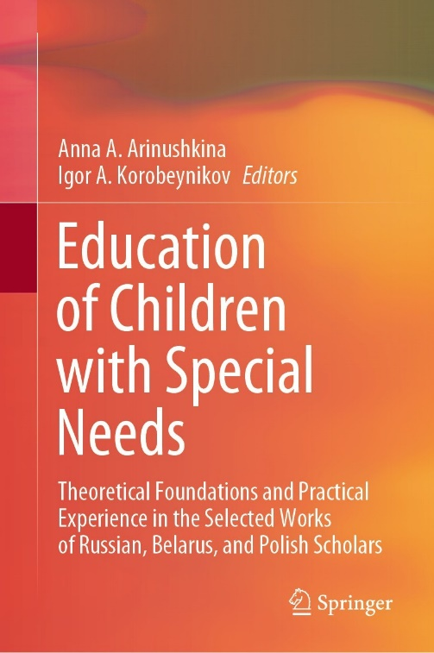 | Titova, O.V., Abkovich, A.Y. (2022). Educational Results of Learners with Motor Impairments Obtained During the Implementation of the New Law on Education. In: Arinushkina, A.A., Korobeynikov, I.A. (eds) Education of Children with Special Needs .Springer, Cham. https://doi.org/10.1007/978-3-031-13646-7_33

Abstract
The implementation of the law “On Education in the Russian Federation” provides for the right of schoolchildren with special educational needs to receive a quality education in special conditions, which consider the peculiarities of their development. Conditions for meeting the special educational needs of schoolchildren are created in special schools and inclusive education organizations. The creation and implementation of special conditions for learners with motor impairments should significantly improve the quality of education for persons of this category. However, there is no research to assess the quality of education for children and adolescents with motor impairments. Methodological approaches to conducting such researches have not been developed, and there are no criteria for assessing the quality of education, considering the existing disorders and their combinations. Thus, the relevance and novelty of this research are determined. The paper aims to investigate the level of educational results of schoolchildren with motor impairments, identify the peculiarities of their development, and consider the implemented variants of adapted programs. The research results allow assessing the educational achievements of schoolchildren with motor impairments. The obtained data allow determining the individual educational route of persons with motor impairments, building the optimal trajectory of professional education, planning budget-funded places in professional organizations, defining quotas for the employment of persons of this category, and regulating the system of special conditions creating for obtaining an education. The relationship between the characteristics of the development of learners and their educational results has been revealed. The main methods of the research include the analysis of the results of state certification, questionnaires, and structured interviews. The presented empirical data confirm the assumption that the educational results of children with motor impairments depend on their individual characteristics and the special conditions created for obtaining an education. The obtained data can help improve the system of education of schoolchildren with motor impairments, as well as the quality of their education.

Keywords
Children with motor impairments; Quality and performance of education; Special conditions; Individual educational path; Survey

