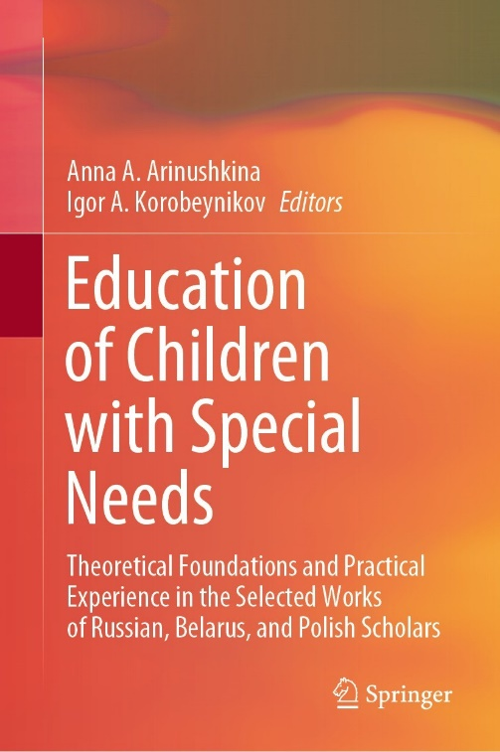 | Marina V. Pereverzeva, Alina Yu. Khokhlova (2022) Ways to Develop Actions with Objects in Children from 2 to 8 Years of Age with Severe Visual, Auditory, and Motor Impairments. In: Arinushkina, A.A., Korobeynikov, I.A. (eds) Education of Children with Special Needs .Springer, Cham.  https://doi.org/10.1007/978-3-031-13646-7_17

Abstract
The paper focuses on the problem of organization and content of education of children from two to eight years old with Severe multiple disabilities SMD. The research relevance is conditioned by the fact that such children start attending educational institutions from an early age. However, the methods and techniques of teaching children with SMD are underrepresented in scientific research. The research involves 120 children from two to eight years old with various combinations of visual, hearing, intellectual, motor, speech, and behavior disorders. The experimental work was conducted in Sergiev Posad boarding school for deaf-blind children and young adults. The research methods include the analysis of medical and pedagogical documentation, structured observation, method of expert evaluations, and pedagogical experiments. The experimental study of the peculiarities of development of actions with objects in children with different combinations of sensory, intellectual, motor, and other impairments highlighted the criteria for assessing the child’s ability to act with objects appropriately. Varying levels of development of children’s abilities to appropriately act with familiar objects were described and implemented in the individual educational programs. The research results show a connection between the ability to act appropriately with familiar objects, the child’s age, and the duration of the learning experience. The authors reveal the correlation between the success in daily living skills and the level of actions with objects. Thus, the results indicate the necessity of paying special attention to the development of object matter activity in work with children with SMD. It makes the world clearer and more accessible for the child. It makes the child as independent as possible, and it improves the quality of life of the child and his or her family. For the first time, it was concluded that the formation of the ability to act appropriately with objects in a child and his or her understanding of the action should become primary components of educational programs for children with SMD. This conclusion was considered in the new educational program for children with SMD, recommended for all educational institutions in Russia.

Keywords
Multiple disabilities, preschool age, object matter activity, evaluation criteria, levels of object matter activity development, individual educational program

