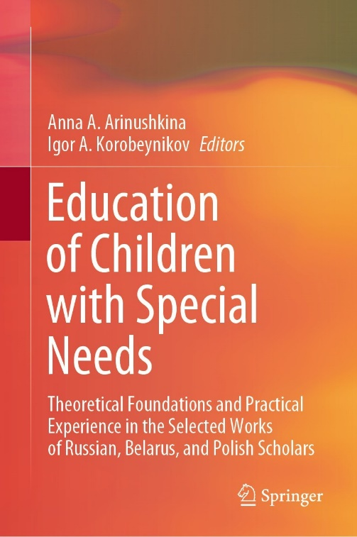 | Mishina, G.A., Gharamyan, B.G., & Sysoeva, I.V. (2022). Anxiety Levels of Adolescents with Impairments at Dental Appointment. In A.A. Arinushkina, & I.A. Korobeynikov (Eds.), Education of Children with Special Needs: Theoretical Foundations and Practical Experience in the Selected Works of Russian, Belarus, and Polish Scholars (pp. 465-472). Cham, Switzerland: Springer. https://doi.org/10.1007/978-3-031-13646-7_48

Abstract The paper focuses on the search for psychological and pedagogical conditions to improve the effectiveness of dental care for children with impairments. It is known that high levels of anxiety, phobic reactions, aggression, and impulsivity influence the success or failure of completing an appointment with a dentist. The paper aims to investigate the level of anxiety and aggression in adolescents with different types of dysontogenesis at dental appointments. Adolescents with attention deficit and hyperactivity disorder (ADHD), cerebral palsy (CP), and impaired hearing participated in the study. The diagnostic tools were represented by the Bass-Darki questionnaire and the Reactive and Personality Anxiety Rating Scale (Spielberger, Khanin). The obtained results indicate significant differences in the manifestations of aggression and personality anxiety in adolescents with ADHD and cerebral palsy as opposed to adolescents with hearing impairment. Statistically significant differences were obtained in the level of reactive anxiety in the group of adolescents with ADHD, who retained its high values both before and after dental care. The authors conclude that knowledge of the type of dysontogenesis will help dentists individualize the route of dental care and successfully complete a dental appointment for such patients.

Keywords Dental appointments • Adolescents with impairments • Anxiety levels • Individualization of the route • Psychological and pedagogical support

