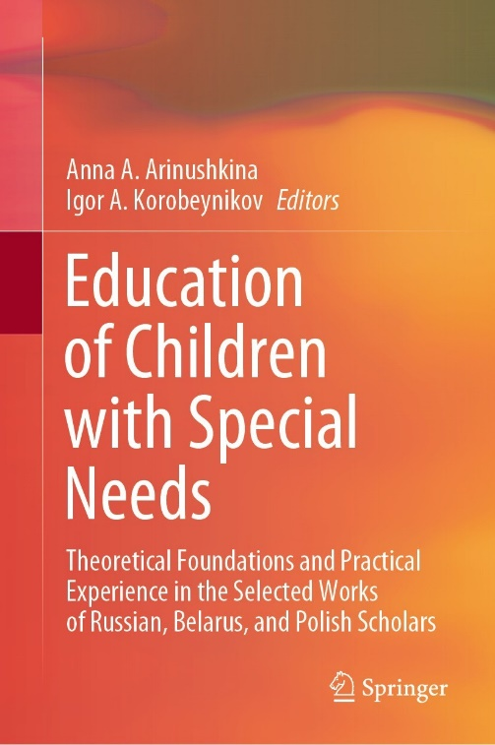 | Mishina, G.A., & Ivleva, O.V. (2022). Speech Therapy with Non-speaking Children with an Intellectual Disability Complicated by Autism Spectrum Disorder. In A.A. Arinushkina, & I.A. Korobeynikov (Eds.), Education of Children with Special Needs: Theoretical Foundations and Practical Experience in the Selected Works of Russian, Belarus, and Polish Scholars (pp. 353-360). Cham, Switzerland: Springer. https://doi.org/10.1007/978-3-031-13646-7_36

Abstract The paper describes the situation in Russian speech therapy with children with an intellectual disability complicated by autism spectrum disorder. The paper aims to conduct a comparative analysis of the content of the concept of speech, analyze the leading international and Russian theoretical and practical approaches, and methodologically substantiate the content of correctional assistance to children with an intellectual disability complicated by the autism spectrum disorder at the initial stage of speech therapy work. The authors highlight the theoretical and practical problems faced by speech therapists in the current conditions of digitalization of the educational environment. The authors present the principles of speech therapy with children with intellectual disabilities complicated by the autism spectrum disorder at the initial stage. The research novelty stems from the approach that uses multimedia learning tools to trigger speech in non-speaking children with an intellectual disability. The results of the training experiment showed a significant reduction in the time for establishing emotional and tactile contact between the child and the speech therapist, a considerable reduction in the time to start the speech, and the possibility to fully individualize the approach depending on the child’s level of sensory sensitivity and the level of his or her perception of the surrounding world. The practical implementation of the obtained results will considerably facilitate communication between parents and their child with intellectual disabilities complicated by autism spectrum disorders, change the behavior of a child in a positive direction, and help the child to master the rules of conduct in society thereby contributing to socialization. The developed approach will allow speech therapists to effectively solve the problems of special education.
Keywords. Speech Therapy, Children with intellectual disability complicated by the autism spectrum disorders Digital learning environment Multimedia technology Multimodal approach

