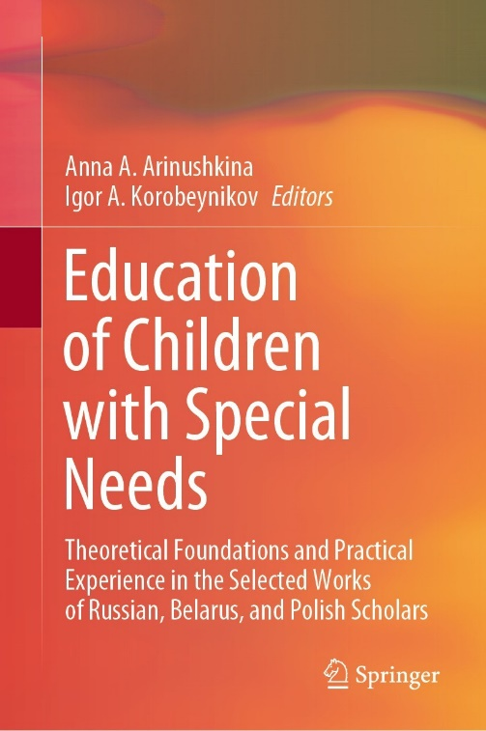 | Boldinova, O.G., Meshcheryakova, A.V., Ivanova, E.A., & Nigmatullina, A.A. (2022). Study of the Competence of Parents Raising a Child with Visual Impairment. In A.A. Arinushkina, & I.A. Korobeynikov (Eds.), Education of Children with Special Needs: Theoretical Foundations and Practical Experience in the Selected Works of Russian, Belarus, and Polish Scholars (pp. 473-480). Cham, Switzerland: Springer. https://doi.org/10.1007/978-3-031-13646-7_49

Abstract: The paper studies the competence of parents raising children with visual impairments (blind or visually impaired). Studying today’s children with visual impairments is not enough to identify their mental and social development. It is critical to determine how competent parents are in determining the need to create special conditions, methods, and techniques to encourage, develop, and adequately form children’s self-esteem and attitude to themselves. The paper aims to assess competence and strategies for educating families raising children with visual impairments. The study involves 229 parents from 26 constituent entities of the Russian Federation. The authors study general information about the family, the child, and the level of parent’s competence. Additionally, the authors determine the strategy for raising children with visual impairments and parental attitudes towards these children and their peculiarities. The findings showed that 59% of surveyed parents feel the need to expand knowledge about their child with visual impairments. It was revealed that parents need to expand cognitive and other skills necessary for the educational and personal activities of a child with visual impairments. The research results can be used to develop tools for assessing the development of the educational and personal activity of children who are blind or visually impaired. Moreover, the results allow improving intrafamilial relationships and increasing parental competence, while positively impact the upbringing and education of a child with profound visual impairment.
Keywords: visual impairment, blind, parents of children who are visually impaired, family, competence, education, personal development.

