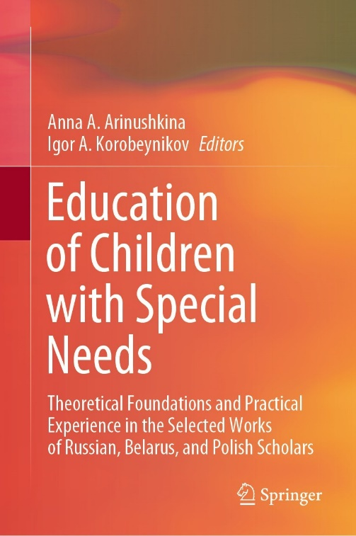 | Abkovich, A.Y. (2022). Modern Tendencies in Development of Educational System of Children and Teenagers with Motor Impairments. In: Arinushkina, A.A., Korobeynikov, I.A. (eds) Education of Children with Special Needs .Springer, Cham. https://doi.org/10.1007/978-3-031-13646-7_19

Abstract
The paper focuses on the key aspects characterizing the educational system of children and teenagers with motor impairments at the level of primary, basic, and secondary general education. The relevant problems and trends in the organization of education of children with motor impairments are considered. The author focuses on the establishment of conditions to meet the special educational needs of schoolchildren. The paper presents a report on the research devoted to studying special educational conditions of schoolchildren with motor impairments in educational organizations of the Russian Federation. Using a questionary method, the author monitors special conditions in 319 inclusive and special schools from 48 regions of Russia with more than 4000 schoolchildren with motor impairments. The monitoring provides objective data on the current system of education of schoolchildren with motor impairments. The specified data reveals the existing problem areas in the organization of education and complex psychological and pedagogical support of schoolchildren with motor impairments. These problems are connected with the qualification of employees in educational organizations, material and technical resources, and program-methodical support, which define priority directions of improvement of the system. Improving the system for teaching schoolchildren with motor impairments in these areas will improve the quality of their education and make the work of teachers and support service specialists more effective.

Keywords
Schoolchildren with motor impairments; Special conditions of teaching
Special educational needs; Special schools; Inclusive schools

