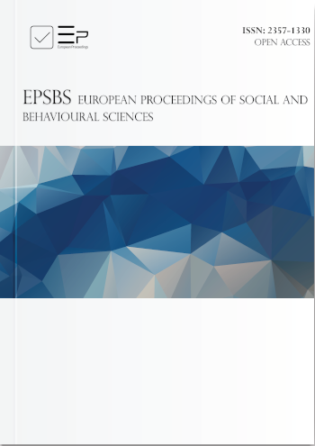
Sviridova T. V., Fisenko A. P., Venger A.V., Afonina M.S., Sklyadneva V.M. Psychological Care For School-Age Patients With Covid-19 At Hospitals For Infectious Diseases // European Proceedings of Social and Behavioural Sciences. Volume 117. - 2021. – pp. 2570-2577/ - DOI: 10.15405/epsbs.2021.11.339

Abstract
The Scientific Medical Research Center for Children’s Health of the Ministry of Health of Russia was the first pediatric center to explore psychological state of 119 children (aged between 6.5 and 17) with COVID-19 during their hospital admission and outline the guidelines for psychological and pedagogical support. The authors analyzed medical and counseling documentation, conducted interviews, observations, screening tests. Based on physical and psychological factors (the main psychological difficulty), the patients can fall into three groups: 5 individuals (4 %) were very ill, with unstable signs of mental activity; 57 individuals (48 %) were mainly in a moderately grave state with severe feelings
associated with the disease; 55 individuals (46 %) were in a satisfactory physical state, with mild and mainly situational difficulties in adapting to a hospital environment, and 2 individuals (2 %) were in a satisfactory physical state, in a relatively stable positive psychological state. Keeping track of physical and psychological severity and the main psychological difficulties allows hospital staff to provide children and adolescents with differentiated psychological care in specific “red zone” conditions.

Keywords: Covid-19, psychological care, psychological care, pediatric center

