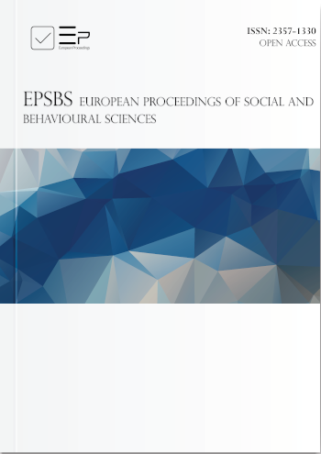
Lazurenko S. B., Pavlova N.N., Sklyadneva V.M. System of Psychological and Pedagogical Assistance to Young Children in Russia // European Proceedings of Social and Behavioural Sciences. Volume 117. - 2021. – pp. 2253 – 2260. - Doi: 10.15405/epsbs.2021.11.298

Abstract
The subject of the study is the essential characteristics of the system of psychological and pedagogical assistance in the Russian Federation as one of the important social components and objective characteristics of the state policy in relation to young children with disabilities, reflecting its qualitative traits and features. The authors have outlined in detail the main stages of developing the system of medical, psychological and pedagogical assistance to children with disabilities, the results of the scientific search for effective methods of clinical and psychological and pedagogical diagnostics, correctional and pedagogical technologies. The creation of these technologies contributed to education system and improved the early psychological and pedagogical assistance to children with mental disabilities. The study emphasizes the role of the Institute of Correctional Pedagogy in the organizing and conducting of scientific research to create a scientific concept of the system of psychological and pedagogical assistance to young children with "high risk" of mental development disorders. It is implemented through a comprehensive analysis of the dynamics of establishing and developing the state system of psychological and pedagogical assistance. The methodological basis of the study is based on the fundamental principles of correctional pedagogy, the principles of scientific objectivity, consistency and complexity, which allow us to study the essential characteristics of the system of psychological and pedagogical assistance to young children in the Russia. The novelty lies in rethinking the conceptual foundations of the development process and the current state of the system of psychological and pedagogical assistance to young children.
Keywords: Children, special education, early intervention

