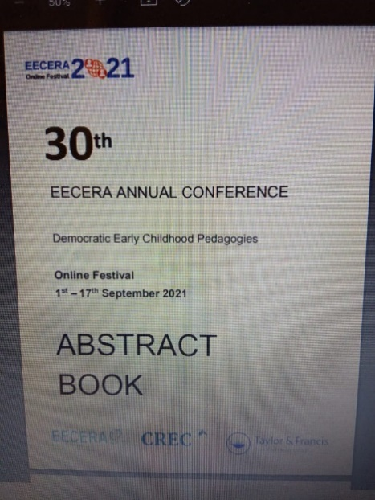Multimedia technologies in speech therapy for children with severe developmental disorders (mental retardation and ASD) Presenter(s): Galina Mishina, Institute of Special Education of the Russian Academy of Education, ISE RAE, Russia Olesya Ivleva, Educational Centre, Gukovo, Russia1-17.09.2021, Загреб, Хорватия
Аннотация. The four-year study was aimed at finding effective technologies for triggering language in nonverbal children with severe disabilities (mental retardation and ASD) at the initial stage of speech/language therapy. Language therapy for children is based on the psychoanalytic, behavioral or psycholinguistic approaches (Haustov, 2008) and aimed at developing communication skills (Peeters, 1999). The most optimal combination of IKT and traditional approaches, which ensures the maximum efficiency of special education (Karpenkova, 2017). The theoretical basis for the research is based on multisensory approach, engaging more than one sense at a time (Obaid, 2012), that provides individualization of learning. The study was based on the cultural-historical psychology (Vygotsky, 2000), considering speech not only as a means of communication, but also as a psychological mediator for managing one's own behavior, which leads to the development of higher mental functions (Mishina, 2012). We used the experimental genetic method (L.Vygotsky, 2000) and quantitative and qualitative analysis of data before and after the training experiment. Ethical guidelines were considered. The parents were informed about research aims and their right to withdraw from the study, written consent was collected. All data were anonymised. The results showed the use of ICT at the initial stage of speech/language therapy made it possible to facilitate and accelerate the formation of tactile-visual contact, significantly reduce the time for triggering language in nonverbal children with severe disabilities. The results of our research help practitioners to reduce manifestations of field cild's behavior in the classroom, to increase child's motivation for therapy classes.
Keywords Intellectual disability and ASD; multisensory approach; information communication technology (ICT); speech/language therapy; cultural-historical psychology

