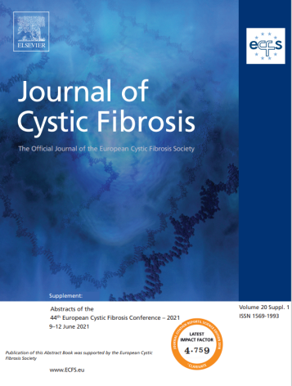
T. Sviridova, S. Lazurenko, A. Gerasimova, A. Golubchikova
Directions of psychological and pedagogical support of children with cystic fibrosis//Journal of Cystic Fibrosis. – 2021. – №20 Suppl. 1. 123. – PP. 117.

Objectives: In order to determine the direction of the psychological and pedagogical support, we provided a study of 75 children with cystic fibrosis (CF) (7–17 years old).
Methods: The analysis of medical literature and Child Behavior Checklist.
Results: Children with CF can be classified into 2 groups: the first - patients with a lifestyle and the trajectory of personality development close to the norm - 45%; the second - schoolchildren whose lifestyle and trajectory of personality development is significantly different from the norm - 55%. For most patients in the first group, a satisfactory condition is noted, a late manifestation of the disease and its mild course. The state of health allows the children to lead a lifestyle close to the social functioning of healthy peers for a long time. In cases where children and adolescents` health worsens, it can be observed that their mood decreases and emotional liability increases. These are being accompanied by children and adolescents` outliving of negative feelings caused by social restrictions. Patients combined into the second group show moderately bad physical condition, moderate/severe course of the disease and its early manifestation. Due to pronounced physical limitations and peculiarities of personal development, their lifestyle differs significantly from healthy peers. A distortion of personality development for these patients, which manifests itself in the form of the immaturity of the development of self-consciousness, needs and interests, cognitive deficit, and a low degree of autonomy in behaviour and communication, can be observed. Their psychological state is largely determined by educational attitudes and the attitude of parents to the disease. In the background is inconsistency of social conditions with their psychophysical needs. The identified psychological features indicate the need for a differentiated approach to psychosocial support for children with CF, which is a study perspective.

