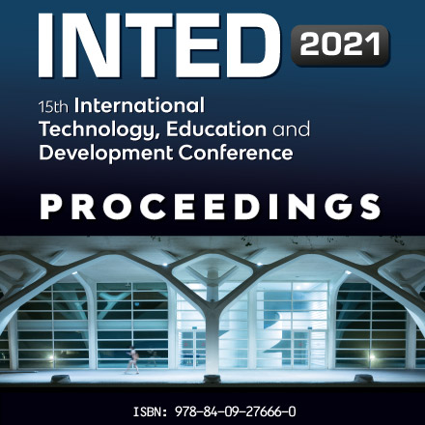
V. Skliadneva, S. Lazurenko, A.Golubchikova, I. Nurlygayanov Analysis of the play aids didactic possibilities for children with the nervous system diseases // INTED2021 Proceedings. Barcelona. – 2021. – pp. 8996-9001. doi: 10.21125/inted.2021.1881.

Abstract
Didactic aids for correctional and pedagogical classes with children with nervous system diseases should correspond to the current psychological age, the nature and severity of the limitations on the vital activity of children, contain special developmental components, including a high degree of intensity of sensory influence, all these jointly will allow realizing the children's existing psychological potential.
Keywords: Nervous system diseases, vital functions restrictions, special educational needs, special education, didactic aids.

